|  |  |  |  |  |
| --- | --- | --- | --- | --- |
| Version | Meeting ID | Editor | Recheck | Change |
| 1.01.20141129 | 12 | Super |  | First version |
| 2.01.20141215 | 18 | Super |  | Changed the execution view |
|  |  |  |  |  |
|  |  |  |  |  |
|  |  |  |  |  |
|  |  |  |  |  |

1. Code View
2. Build View

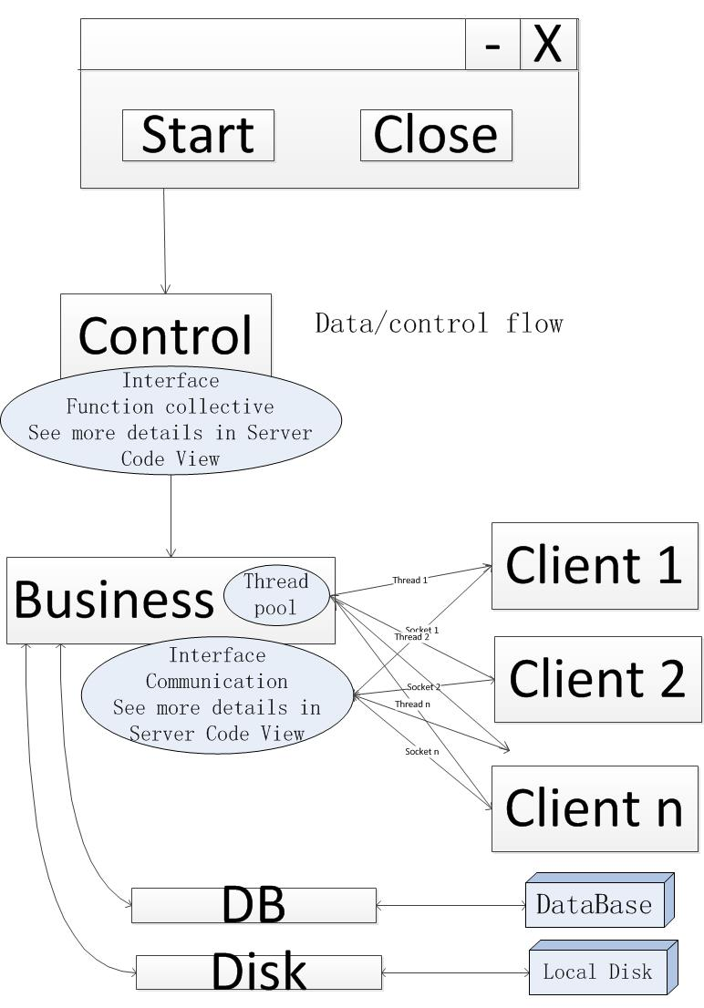

1. Execution View

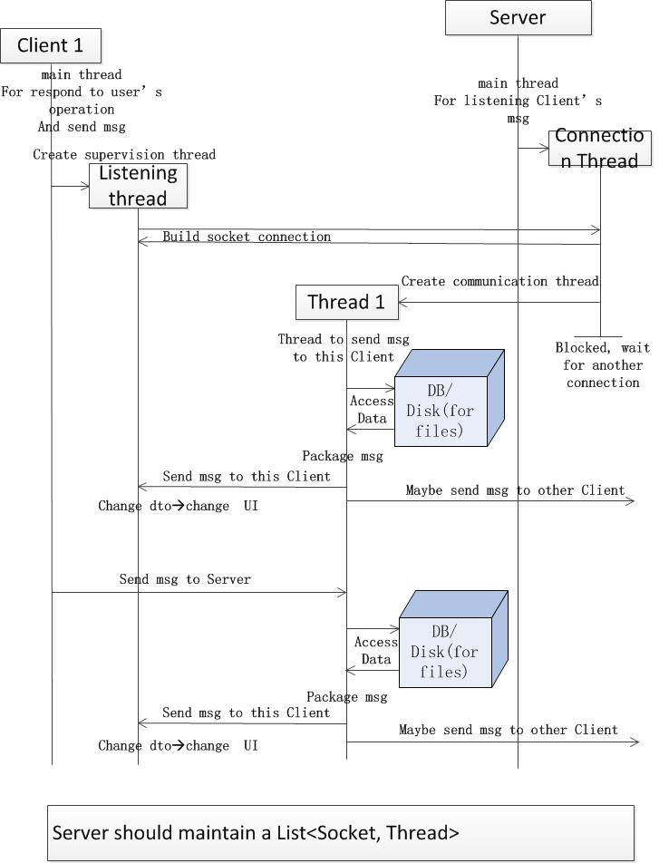

1. UML Class diagram